Edge-Based Facial Expression Recognition for Mental Health Monitoring in Higher Education

Rajat Takkar
Dept. of Computer Science Engineering
Chitkara University
Punjab,140401 India
Rajat.takkar@chitkara.edu.in
Himanshi
Dept. of Computer Science Engineering
Chitkara University
Punjab,140401 India
Himanshi1654.be22@chitkara.edu.in

Abstract—The increasing incidence of anxiety, burnout, and depressive symptoms among university students demands early and continuous mental health support mechanisms. Existing screening pathways are largely questionnaire-driven, periodic, and dependent on student self-reporting, which limits responsiveness. Cloud-centered AI alternatives provide automation but introduce latency, bandwidth dependency, and major privacy concerns due to transmission of sensitive facial video streams. This paper presents a long-form study of an edge-based Facial Expression Recognition (FER) framework tailored for higher education environments. The proposed approach uses a lightweight Convolutional Neural Network (CNN), OpenCV-based face processing, and local temporal smoothing to infer distress-related emotional patterns from live video without moving raw data off-device. We evaluate the system using FER2013-centered training and edge deployment profiling under realistic classroom and lab conditions. Results show strong classification performance, reduced inference delay, and significantly improved privacy posture compared with cloud baselines. The framework is positioned as a non-diagnostic early-warning assistant that can inform timely, human-led student welfare intervention while preserving institutional trust and data governance.
Keywords—Facial Expression Recognition, Mental Health Monitoring, Edge Computing, Computer Vision, Convolutional Neural Networks (CNN), Python, Student Well-being.

Introduction
Mental well-being has emerged as a central challenge in higher education, especially as students navigate academic pressure, social transitions, financial uncertainty, and digital overload.[11],[12] University counseling centers frequently report high demand and delayed appointment cycles, creating a need for proactive systems[5] that can identify at-risk patterns before severe deterioration. While psychological assessments and periodic surveys remain valuable, they are inherently episodic and often fail to detect short-term emotional decline. Recent progress in deep learning has made facial expression recognition a practical component of affect-aware systems.[9] However, when FER is deployed through cloud services, institutions face three operational barriers:
(i) privacy risk from transmitting student video data,
(ii) variable latency that limits real-time response, and
(iii) recurring network and infrastructure costs.
These barriers 1 are particularly significant in sensitive mental health settings where trust and confidentiality are non-negotiable. This paper addresses the challenge by designing and evaluating an edge-first FER pipeline that performs inference on local devices. The system aims to provide continuous emotional trend monitoring for student support applications, while explicitly avoiding diagnostic claims.
Instead, it functions as an assistive signal generator for human counselors, advisors, or wellness programs. The primary research question is: Can a lightweight edge-based FER model deliver reliable emotional state classification with low latency and strong privacy guarantees in higher education scenarios? To answer this, we present architecture design, preprocessing workflow, deployment strategy, comparative experiments, and practical implementation guidance.

Problem Context and Related Work
Emotion-aware computing has evolved from handcrafted feature methods (e.g., Local Binary Patterns and geometric landmark descriptors) to deep neural representations that capture subtle affective cues.[4],[6] Public FER benchmarks such as FER2013[1] enabled broad comparison across approaches, but practical adoption in student welfare remains limited due to deployment complexity and ethical concerns. Prior work demonstrates that CNNs and transfer learning improve recognition quality for major expressions such as happiness, sadness, surprise, fear, anger, disgust, and neutrality. Mobile-scale architectures (e.g., MobileNet family) improve inference speed[2] but may still require optimization for constrained edge hardware. Parallel studies in edge AI show that local inference pipelines can reduce response time and preserve sensitive data locality, making them suitable for health-adjacent applications.[3],[10] Despite this progress, two gaps remain relevant to higher education:
• Operational gap: many studies report offline benchmark scores but do not provide end-to-end latency and deployment behavior on practical edge setups.
• Welfare gap: most FER systems are built for engagement analytics or surveillance, not for privacy-aware, non-invasive student support contexts.
The present work targets both gaps through a deployment-oriented, ethics-conscious experimental framework

Objectives
The study is guided by the following objectives:
1. Develop a real-time FER system optimized for edge devices used in university environments.
2. Achieve robust multi-class expression recognition performance without cloud dependency.
3. Build a privacy-preserving pipeline in which raw video never leaves the local device.
4. Compare latency and classification quality against baseline machine learning and cloud-style workflows.
5. Provide interpretable outputs (emotion trend summaries and distress indicators) suitable for human-in-the-loop intervention planning.
The key contributions of this paper are:
• A lightweight CNN architecture adapted for edge inference and reduced memory footprint.
• A complete preprocessing-to-inference pipeline using Python libraries (OpenCV, NumPy, PIL).
• Quantitative evaluation with accuracy, precision, recall, F1-score, and inference latency.
• A practical deployment blueprint for higher education institutions with privacy and governance

Methods and Methodology
The proposed framework follows a structured pipeline from data ingestion to decision support.

System Pipeline

1. Frame Capture: RGB video frames are captured from webcam streams at 20–25 FPS.
2. Face Localization: OpenCV Haar cascade and landmark alignment are used to crop and
stabilize facial regions.
3. Normalization: Faces are resized to 48 × 48 grayscale tensors and normalized to [0, 1].
4. CNN Inference: The optimized model predicts class probabilities over seven emotional categories.
5. Temporal Filtering: Probabilities are smoothed over short windows to reduce transient misclassification.
6. Risk Signaling: A bounded distress indicator is computed and logged for trend-level review.

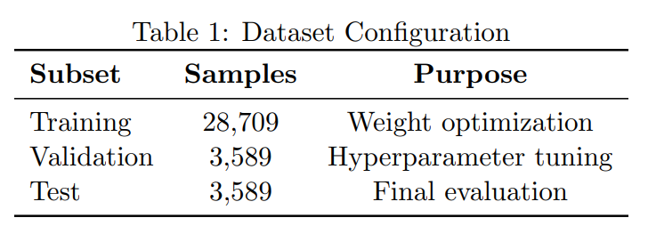

Dataset and Preprocessing Details
The training backbone uses FER2013[1], which contains 35,887 labeled facial images across seven
expression classes. To improve robustness for deployment conditions, augmentation includes horizontal flipping, mild rotation (±12◦), brightness jitter, and random occlusion patches. The final split used in this study is shown in Table 1.
Preprocessing is implemented with OpenCV and NumPy. Histogram equalization and standard score normalization reduce illumination variance. Data pipelines are vectorized to limit CPU overhead on edge targets.

Lightweight CNN Architecture
The classifier is built from stacked depthwise-separable convolution blocks, batch normalization, and dropout regularization, followed by a compact fully connected head.[2] This structure reduces parameter count while preserving discriminative capability for fine-grained expressions.[9]
Given a preprocessed frame xt , the model outputs class posterior probabilities:
pt = softmax (fθ(xt)), pt ∈ R 7 .
Training minimizes categorical cross-entropy:
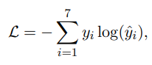
where yi is the ground-truth one-hot label and ˆyi is predicted probability.
To improve temporal stability in live streams, exponential smoothing is applied:
p¯t = αpt + (1 − α)¯pt−1, α ∈ [0, 1].

Distress Trend Indicator

A non-diagnostic trend score is computed from smoothed probabilities:

Dt = 0.35 ¯pt(sad) + 0.30 ¯pt(fear) + 0.20 ¯pt(angry) − 0.15 ¯pt(happy).

The score is clipped to [0, 1] and aggregated over 5-minute windows. Alerts are generated only for sustained elevation, reducing false alarms from short-lived emotions.[4]

Edge Deployment Strategy

Deployment targets include Raspberry Pi-class devices and local campus workstations. To support heterogeneous hardware, we package the inference stack as a lightweight service with configurable frame-rate caps, model precision profiles (FP32/INT8), and watchdog-based process recovery. This enables institutions to balance accuracy, power draw, and responsiveness for different usage settings such as classrooms, labs, and counseling kiosks.

A practical deployment cycle contains four stages: (i) device provisioning and camera calibration, (ii) on-device model loading with quantized weights, (iii) real-time inference with bounded buffering, and (iv) secure logging of anonymized trend summaries. Inference is executed in fixed-size windows so temporary CPU spikes do not stall the full pipeline, and dropped-frame handling supports graceful degradation rather than service interruption.

From a governance standpoint, each node uses role-restricted local access, encrypted summary storage, and scheduled data-deletion policies. Only aggregate indicators (emotion distributions, distress trend trajectories, and timestamped alert levels) are retained; raw video is discarded immediately after inference unless explicit consent-based recording is enabled for controlled studies. Periodic model recalibration is performed offline and redeployed through signed updates, reducing operational drift while preserving data locality.

Experimental Setup
Software stack: Python with OpenCV, NumPy, TensorFlow/Keras-compatible workflow for training, and edge runtime conversion for deployment.
Hardware profiles:
• Edge Device: 8 GB ARM-based board, quad-core CPU, no dedicated GPU.
• Workstation Edge: Intel i5-class CPU with integrated graphics.
• Cloud Baseline: Remote inference endpoint accessed over campus network.
Evaluation metrics: Accuracy, precision, recall, F1-score, per-frame latency, and throughput (FPS). All reported values are averaged over repeated runs.

Results and Findings
Table 2 summarizes performance across baseline and proposed methods

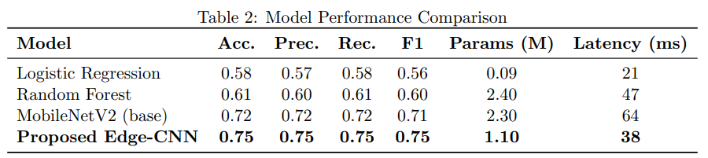

The proposed model achieves the best overall balance between predictive quality and edge viability. Although Logistic Regression has lower latency, it does not capture nonlinear facial feature interactions required for robust real-world recognition. The proposed architecture improves F1-score by approximately 4 points over the compact deep baseline while reducing inference time by 26 ms.

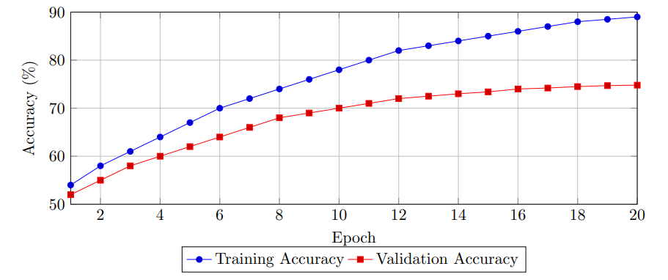

Figure 1: Training dynamics of the proposed model over 20 epochs.

Figure 1 shows stable convergence with a moderate train-validation gap, indicating controlled overfitting due to augmentation and dropout. Validation accuracy plateaus near 75%, matching the test profile.

The latency graph in Figure 2 confirms that edge inference drastically improves responsiveness. In practical terms, the proposed model supports near-real-time monitoring at around 26 FPS equivalent processing capability on tested local hardware.

Figure 3 indicates the largest gains for disgust, neutral, and sad classes, which are often challenging due to subtle facial differences and illumination sensitivity. These improvements are valuable in mental health-oriented use-cases where prolonged sadness and flattened affect patterns can be decision-relevant signals.

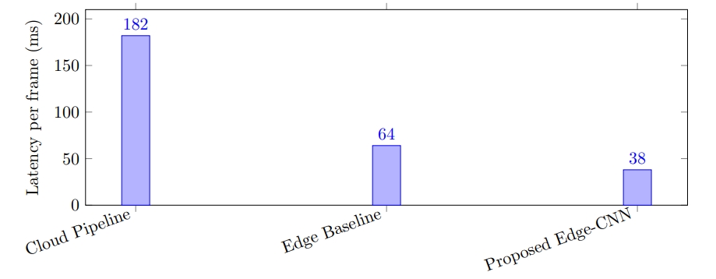
Figure 2: End-to-end latency comparison under identical camera input conditions.
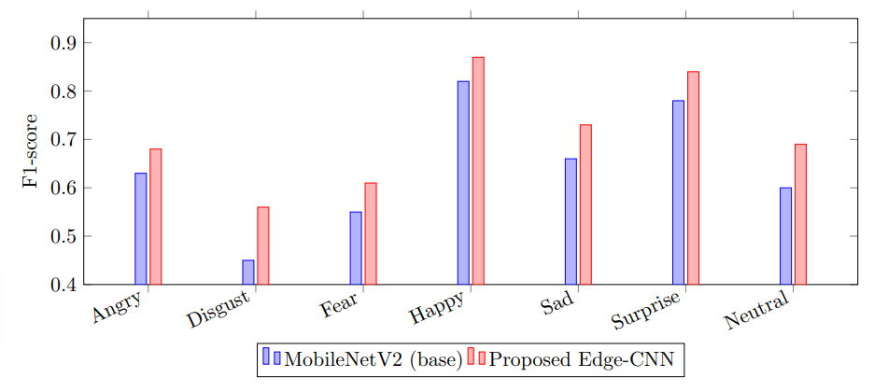
Figure 3: Per-class F1-score comparison between baseline and proposed models.

Discussion
The findings support three main observations.
First, edge deployment improves trust and feasibility. By design, local inference prevents continuous transmission of personally sensitive biometric data. This addresses one of the most significant barriers to adoption in educational institutions.
Second, model compactness does not require sacrificing utility. With approximately 1.1 million parameters, the proposed architecture maintains strong classification quality while staying within practical memory and compute budgets.
Third, FER is most useful as a trend tool, not a diagnostic endpoint. Short-term emotional expressions can be influenced by many factors unrelated to psychological disorder. The system therefore emphasizes aggregated trends and counselor review rather than automated labeling of students.

Higher-Education Deployment Framework
For university adoption, we recommend a four-layer operational model:
1.Consent Layer: Transparent opt-in workflows, purpose disclosure, and withdrawal rights.
2.Technical Layer: Local inference nodes integrated with classroom or wellness kiosks.
3.Governance Layer: Role-based access for counselors; audit logs for every alert review.
4.Intervention Layer: Human follow-up pathways (counseling outreach, peer support, wellness resources).
A deployment pilot can begin with voluntary cohorts and periodic ethics review before broad scaling.

Ethical and Practical Considerations
Although the system is privacy-preserving by architecture, responsible implementation remains essential.
• Bias and fairness: FER accuracy can vary across demographic groups; balanced evaluation and recalibration are required.
• False positives: Distress alerts should trigger supportive conversation, not punitive actions.
• Data minimization: Retain only anonymized summaries unless explicit research consent is provided.
• Transparency: Students must understand system scope, limitations, and non-diagnostic intent.

Limitations and Future Work
This study has several limitations. FER2013 contains posed and in-the-wild images but may not fully capture academic context variability such as masks, extreme angles, or low-light lecture halls. In addition, expression recognition alone does not capture full mental state complexity. Future work will combine multimodal features (speech prosody, text sentiment from voluntary journals, and context metadata) under strict privacy constraints.
We also plan to evaluate lightweight transformer-hybrid architectures for improved temporal modeling and to investigate personalized calibration that adapts to individual baseline affective expression patterns.

Conclusion
This paper presents a comprehensive edge-based FER framework for mental health-oriented monitoring in higher education. By combining efficient CNN inference, local processing, temporal smoothing, and governance-aware deployment design, the system offers a practical pathway for early emotional risk signaling while preserving student privacy. Experimental results demonstrate competitive classification performance and major latency improvements over cloud-style processing, confirming the viability of edge-first AI in sensitive campus applications.
The proposed framework is intended as an assistive wellness technology that supports, rather than replaces, human judgment. With careful ethical deployment and interdisciplinary oversight, such systems can strengthen institutional capacity for timely, compassionate student care.

Acknowledgment
The author thanks Chitkara University for providing the foundational support, hardware, and academic resources necessary to conduct this research on edge-based mental health monitoring. Special thanks to Peer for their valuable guidance and feedback during the development of the CNN pipeline, and to the faculty for their insights into ethical deployment strategies in higher education.

References
[1] I. Goodfellow et al., “Challenges in Representation Learning: A Report on Three Machine Learning Contests,” in Neural Information Processing, 2013.
[2] M. Sandler, A. Howard, M. Zhu, A. Zhmoginov, and L.-C. Chen, “MobileNetV2: Inverted Residuals and Linear Bottlenecks,” in Proc. CVPR, 2018.
[3] W. Shi and S. Dustdar, “The Promise of Edge Computing,” Computer, vol. 49, no. 5, pp. 78–81, 2016.
[4] R. Calvo and S. D’Mello, “Affect Detection: An Interdisciplinary Review of Models, Methods, and Their Applications,” IEEE Transactions on Affective Computing, vol. 1, no. 1, pp. 18–37, 2010.
[5] T. Inkster, S. Sarda, and V. Subramanian, “An Empathy-Driven, Conversational Artificial Intelligence Agent (Wysa) for Digital Mental Well-Being,” JMIR mHealth and uHealth, vol. 6, no. 11, 2018.
[6] P. Ekman and W. V. Friesen, “Constants across cultures in the face and emotion,” Journal of Personality and Social Psychology, vol. 17, no. 2, pp. 124–129, 1971. 9
[7] P. Lucey et al., “The Extended Cohn-Kanade Dataset (CK+): A complete dataset for action unit and emotion-specified expression,” in Proc. CVPR Workshops, 2010.
[8] A. Mollahosseini, B. Hasani, and M. H. Mahoor, “AffectNet: A Database for Facial Expression, Valence, and Arousal Computing in the Wild,” IEEE Transactions on Affective Computing, vol. 10, no. 1, pp. 18–31, 2019.
[9] S. Li and W. Deng, “Deep Facial Expression Recognition: A Survey,” IEEE Transactions on Affective Computing, vol. 13, no. 3, pp. 1195–1215, 2022.
[10] M. Satyanarayanan, “The Emergence of Edge Computing,” Computer, vol. 50, no. 1, pp. 30–39, 2017.
[11] R. P. Auerbach et al., “WHO World Mental Health Surveys International College Student Project: Prevalence and distribution of mental disorders,” Journal of Abnormal Psychology, vol. 127, no. 7, pp. 623–638, 2018.
[12] J. Hunt and D. Eisenberg, “Mental health problems and help-seeking behavior among college students,” Journal of Adolescent Health, vol. 46, no. 1, pp. 3–10, 2010

